BIRTHDAY PARTY CONTRACT
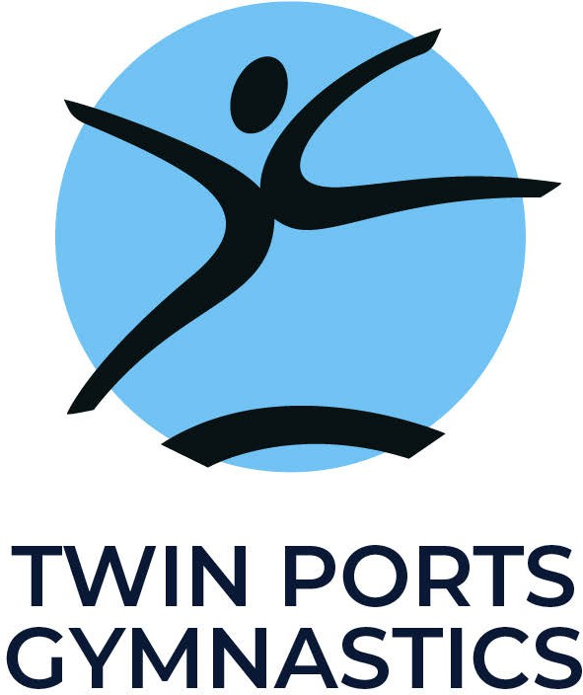

All rentals during regular business hours are based on availability of the facility. To reserve a date/time, a $75 NON-REFUNDABLE deposit is due. The remaining balance is due on the party or rental date.
**Please note all card-based transactions will incur a 3% processing fee.**

CUSTOMER INFORMATION
Child’s Name / | Gr | oup Name:
Child’s Gender: |  |  |  |  | Age of Child / Group: | T-Shirt Size:
Child’s Parent / Contact Person:
Home Phone: |  |  |  |  | Cell: |  | Email:
Address: |  |  |  |  | City: |  | State: | Zip:

PARTY INFORMATION
Party Date: |  | Party Day/Time:
# of Children Participating: |  | Age Range:
Select Party Option:
Would you like to use our 40 ft inflatable obstacle course free of charge?
PARTY REQUIREMENTS
- This contract and $100 deposit MUST be on file at Twin Ports Gymnastics Club at your time of reservation or your date is subject to cancellation.
- Each party includes up to 10 or 20 participants (depending on party package) in addition to the birthday child. Each additional participant over that number is an additional $10.00. The party balance and any additional charge for more than designated participants are due on the party date.
- Parents are responsible for plates, napkins, cups, and etc. needed for the party. We will provide the tables, chairs, tablecloths and minimal decorations.
- The Birthday Child will receive a free TPG T-shirt. All Partygoers receive a goody bag.

- Participants must turn in a signed Party Participation Form at the START of the party or he/she will not be allowed to participate.
- Participants must be dressed appropriately – i.e. no jeans, long hair must be tied up, no jewelry. (Dress in loose fitting clothes for easy movement.) Those who are not dressed appropriately will not be allowed to participate in all of the activities.

PLEASE READ CAREFULLY, PRINT, & SIGN
FOR OFFICE USE ONLY
Party confirmation call - Date:
Staff:

Twin Ports Gymnastics Club, Inc. is an alcohol and tobacco free facility.
The user group agrees to release and hold harmless Twin Ports Gymnastics Club, Inc. and BC Enterprises, LLC from any and all claims, demands, damages, actions, and causes of action of every kind or nature which may occur during the group’s usage or occupancy. Further, the user group agrees to indemnify Twin Ports Gymnastics Club, Inc. and BC Enterprise, LLC for,
- The negligent acts of any agent or representative of the user group and
- The negligent acts of any agent, employee, officer or director of Twin Ports Gymnastics Club, Inc. and BC Enterprises, LLC.
I have read the above information and agree that it represents accurately the arrangement we have requested. The user group is responsible for any damages to the facility and/or equipment.

Parent / Contact Person’s Signature :
Date :

THANK YOU FOR SELECTING TWIN PORTS GYMNASTICS!



Date deposit paid: | Receipt #: |  | Cash/Check #:
Party balance paid: | Receipt #: |  | Cash/Check #:

